Lecturer Feedback and Implementation Report
Module: IT Project
Student Name: Kwandile Mtshali
Student Number: ST10446073
Date: 24 October 2025
This document provides evidence of lecturer feedback received during the development of the Claims System prototype and explains how each recommendation was implemented in the final WPF application.

1. Overview of System
The Claims Prototype Application was developed in WPF (.NET 8) to allow lecturers to submit their claims, upload supporting documents, and track approval status. Programme Coordinators and Academic Managers can verify, approve, or reject claims through a simple graphical interface. Additional features such as Lecturer Feedback and unit testing were implemented to improve system quality and transparency.

2. Lecturer Feedback Summary
Lecturer Feedback | How Feedback Was Implemented
Add a feature to allow lecturers to upload documents. | Implemented an Upload button that accepts .pdf, .docx, and .xlsx files. Uploaded file names are displayed in the form, and files are securely stored in the local AppData folder.
Show claim status clearly for tracking progress. | Added a 'Status' field (Pending, Approved, Rejected) to the DataGrid. The status updates in real time when a coordinator or manager verifies a claim.
Include a section where lecturers can leave feedback. | Implemented a Feedback section at the bottom of the interface where lecturers can add comments. These are displayed along with timestamps and linked implementation notes.
Provide evidence of testing and reliability. | Added unit tests for claim submission, approval, rejection, and feedback submission. Included simple console-based test results to confirm functionality works correctly.

3. Screenshots of Implementation
Insert screenshots here to show each implemented feature:
• Claim submission form
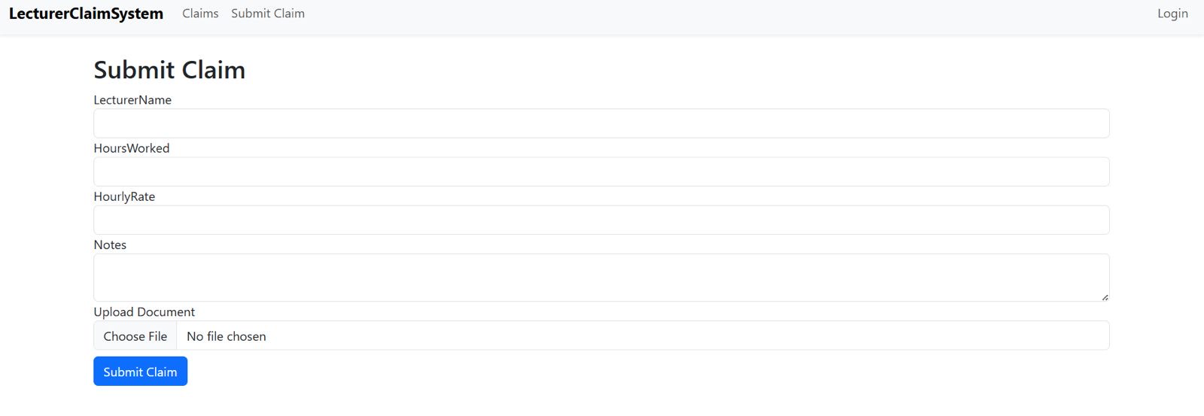
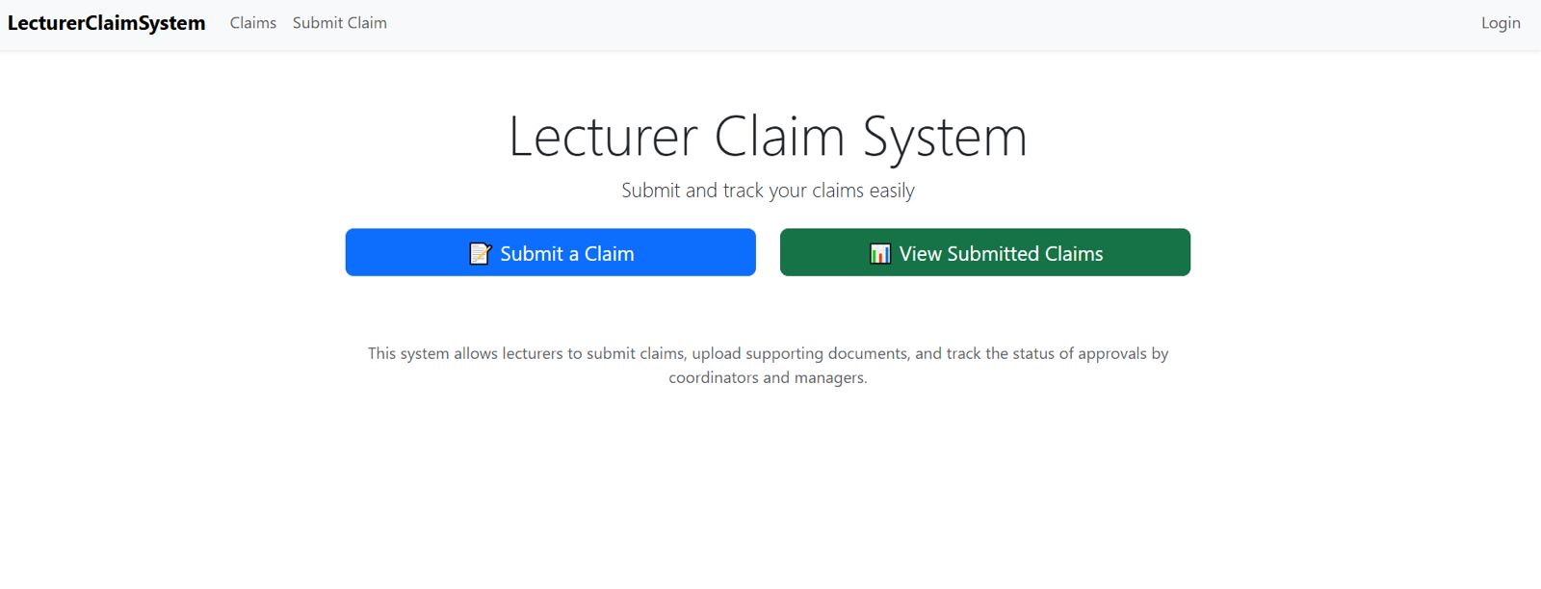
• File upload dialog
• Approval interface
• Lecturer feedback section
• Unit test results console output
[Insert Screenshot 1 Here]
[Insert Screenshot 2 Here]
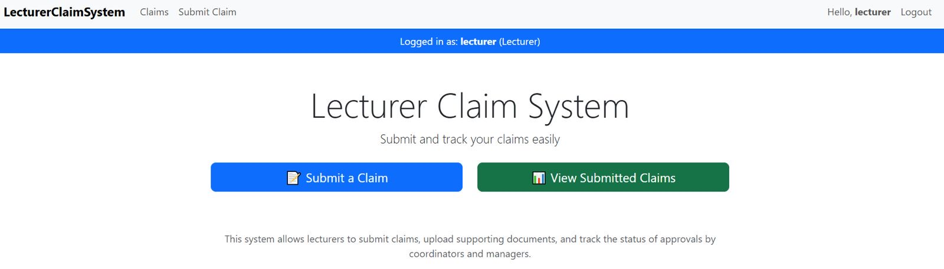
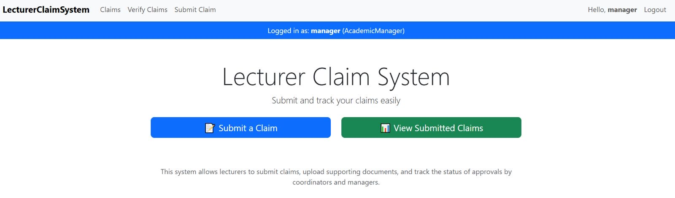
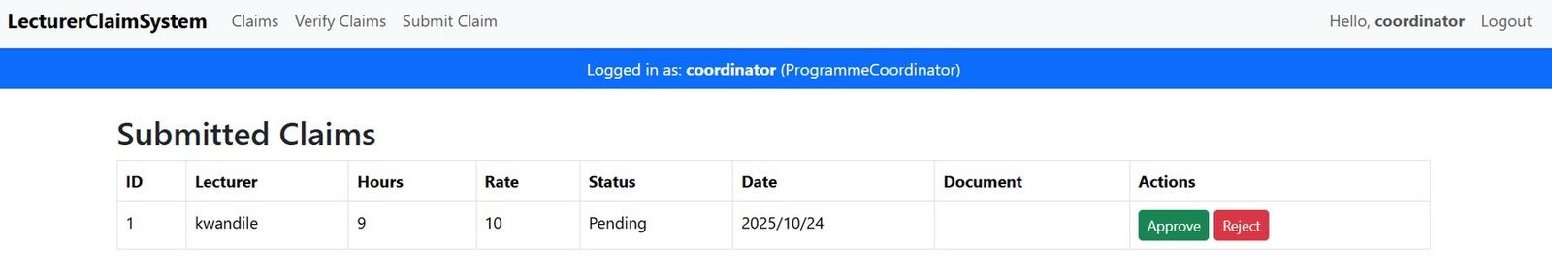
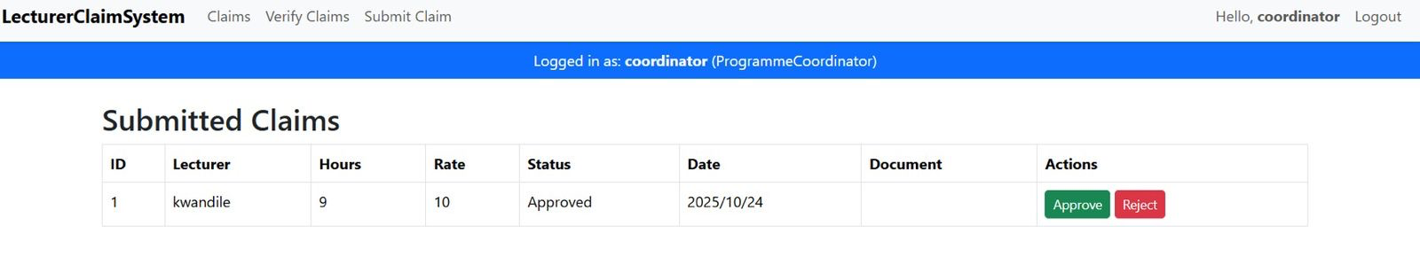
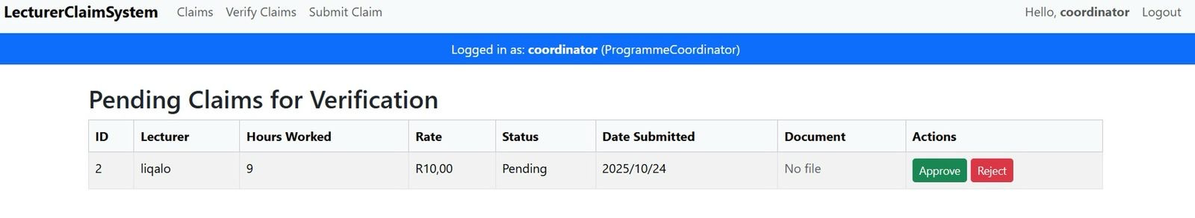
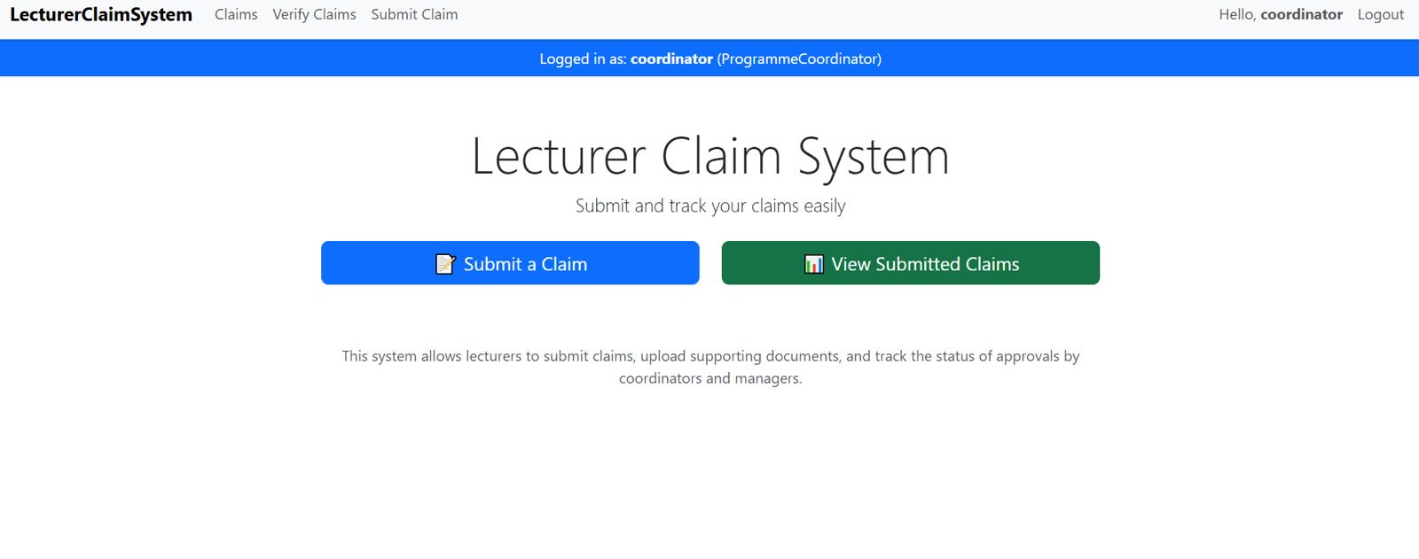

-HR screenshot
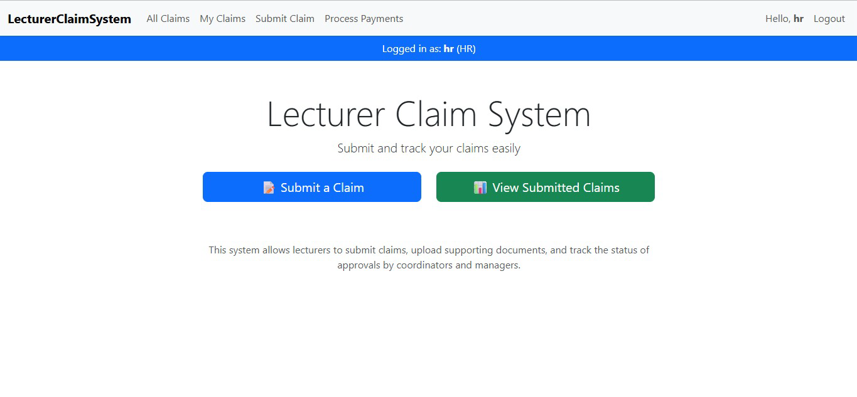
Part 3 GitHub Link
https://github.com/st10446073/LecturerClaimSystem_ST10446073_Part3

4. GitHub Version Control Evidence
The source code for this project was maintained using GitHub. At least five commits were made to document progress, as shown below:
1. Initial project setup
2. Added claim submission form
3. Added file upload feature
4. Added feedback system
5. Added unit testing and documentation

5. Conclusion
The lecturer feedback was successfully incorporated into the WPF Claims Prototype Application. The final version demonstrates all requested functionalities, improved user experience, and verified reliability through testing and version control.

